13 November 2019
TRIAL: ‘Find my Lost’ – digital property solution

We have been working with ‘Find My Lost’ on a digital lost and found property solution as part of the NXIS programme for the last few months.

As part of the programme, we will be running a trial to review the solution and its suitability for our customers and staff. The trial will start from tomorrow (Thursday 14th November). For this trial we will only be using this platform for current coach services between Stansted Airport and London which are operated by National Express Start Hill.

In addition, our Coach Station Team at Stansted Airport will be logging the items that are found within our retail space at the airport which will then be handed to Excess Baggage within the Airport terminal which will allow staff and customers to search for lost and left items. We will also communicate if and when the trial ends and all other lost property items will continue via the existing process.

The ‘Find My Lost’ platform at nationalexpress.findmylost.co.uk allows customers to search found items, report found items, receive notifications on new items logged, as well as messaging the lost property team. The platform comes with an integrated express delivery solution through DHL when an item has been found (an item can also be collected from the Start Hill or Stansted Airport).

Customers will be able to see images of found items, and then request the item (proof of ownership will be required) and then the customer can check out using their paypal account for added security and convenience all of this can be completed within the website, reducing contacts to the centre and giving access to the site 24 hours a day.

Our customers will be directed to the ‘Find My Lost’ website through our FAQs and from the Lost Property section on our website. You can also direct them to nationalexpress.findmylost.co.uk
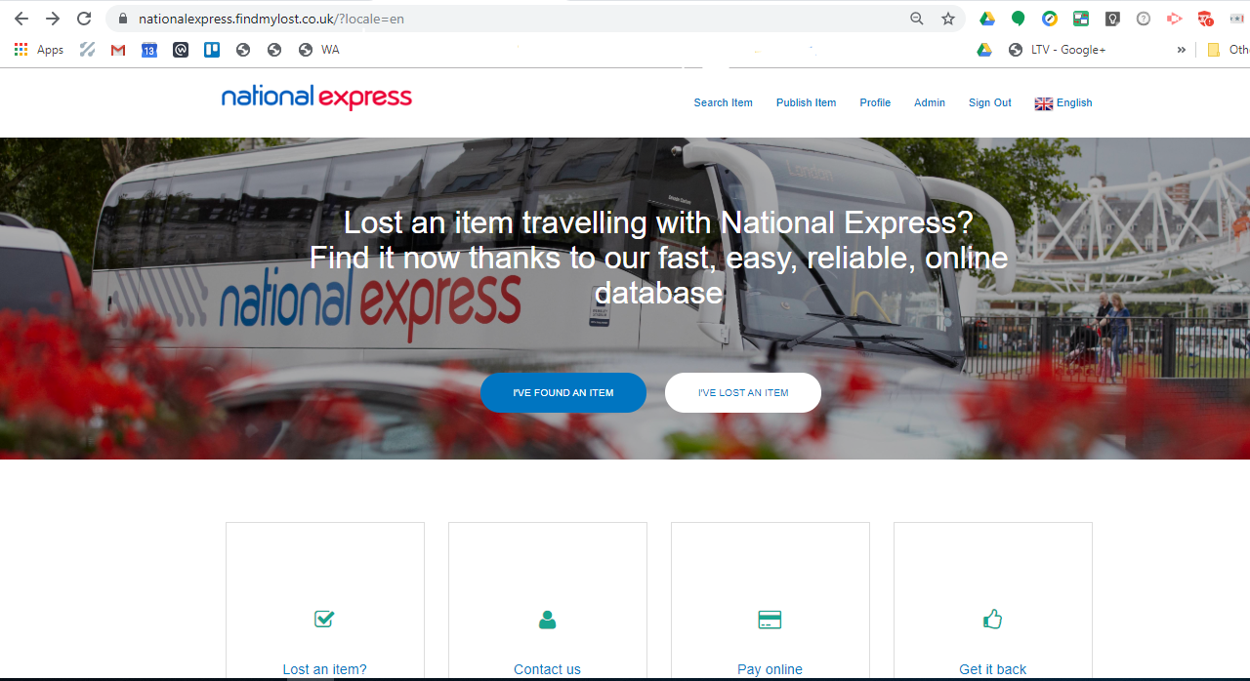
FAQs

Contact Centre:

I have a contact from our customer who has lost and item on an A service (A6, A7, A8 & A9) when travelling between London and Stansted what should I do?
Direct the customer to Find my lost website nationalexpress.findmylost.co.uk for the customer to register and compete a search to locate their lost item.

What if my customer doesn't have internet access?
Explain that items lost and found on this route are handled online with 24 hour access, and maybe asking a friend or family member to support may help as personal email notifications can be set up for the item if it's not initially found online. If your customer does not have any access to the internet then please speak to a Team Manager for support.

Do customers have to have it delivered?
Whilst the express service from DHL will help a number of customers, we recognise that some will want to collect from Start Hill or Stansted Airport. A customer can choose to collect in person (within agreed hours) or have the item shipped.

What are the costs associated?
The lost property (finders) fee is aligned to our current fees, additional fees will apply is the customer requires shipping.

Start Hill Drivers and Stansted and London Victoria Coach:

What do I need to do differently?

Start Hill drivers - continue to hand in any found items to the controllers who will log the items on the Find My Lost site.

If a customer contacts you to advise they have lost an item, and it cannot initially be located then direct the customer to the lost property section of the National Express website for further details.

Stansted Coach Station - Continue your current process and a member of the management will log the item on the Find My Lost site. If you do have any customer contact regarding items left on Stansted A services, please revert them to the Lost Property section on the National Express website for contact details.

Victoria Coach Station - Drivers from A services should continue to take items back to Stansted. If you do have any customer contact regarding items left on Stansted A services, please revert them to the Lost Property section on the National Express website for contact details.
If you have any questions regarding this communication. Please contact Graham Price, Customer Experience Manager, graham.price2@nationalexpress.com / 07899 892 349

